# Examining Factors Responsible for Heart Attacks

# Software Used:

**Python, Tableau**

## Data Preliminary analysis:

1. Dealing with **missing data:**

No missing data

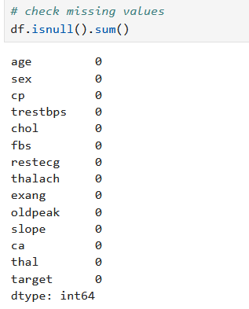

1. Dealing with **duplicates**:

On duplicate found

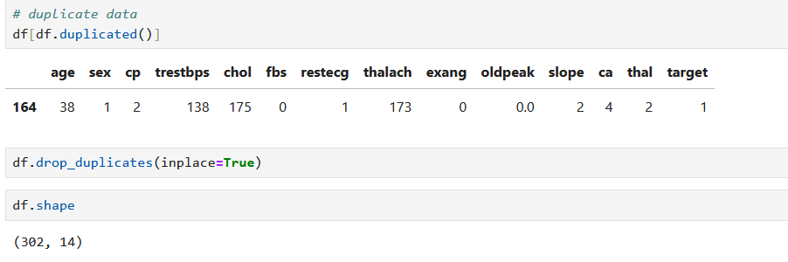

Data shape before :

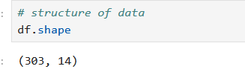

1. **Target plot**

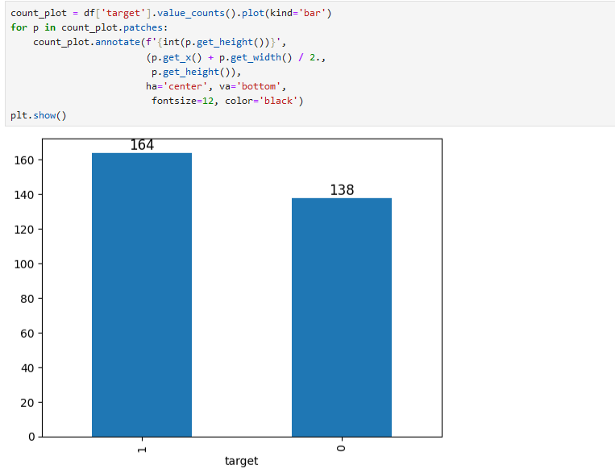

Analysis:

The dataset has a higher number of patients without heart disease(164).

1. **Gender Distribution** w.r.t to **Target:** 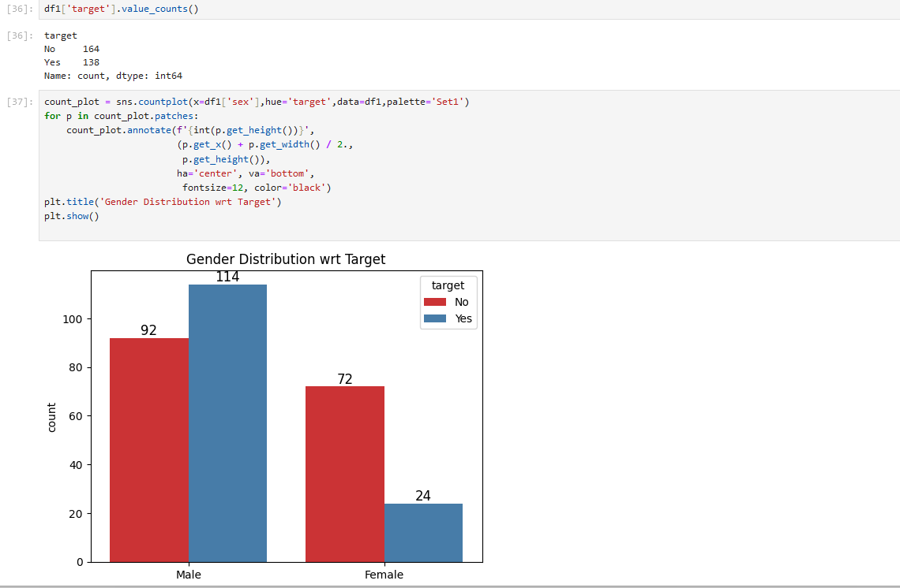

Analysis:

Diseased males are 114 , males have more chances to get heart disease.

1. **Chest Pain w.r.t to Disease**

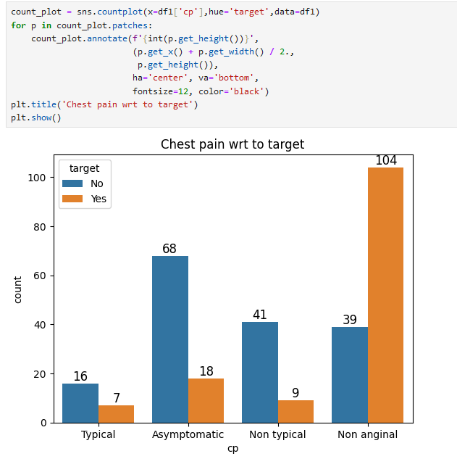

Analysis:

If a certain chest pain type 0 happens more often, it means many patients have non anginal , which can be a sign of heart disease. Other chest pain type have less expectation that he could have a heart disease

1. **Age Vs CVD**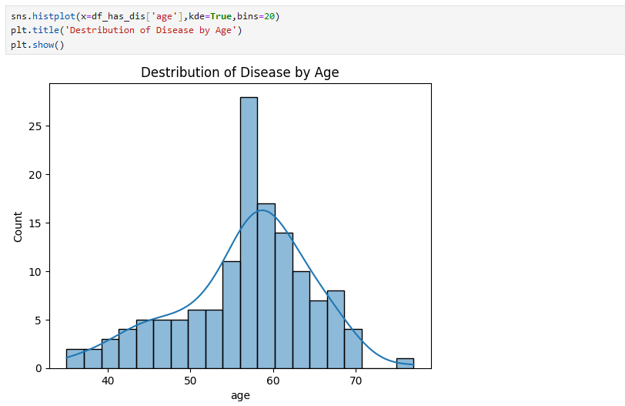

Analysis:

heart disease is more common in that **age group of (50-60 years old)**

1. **Cholesterol level vs CVD**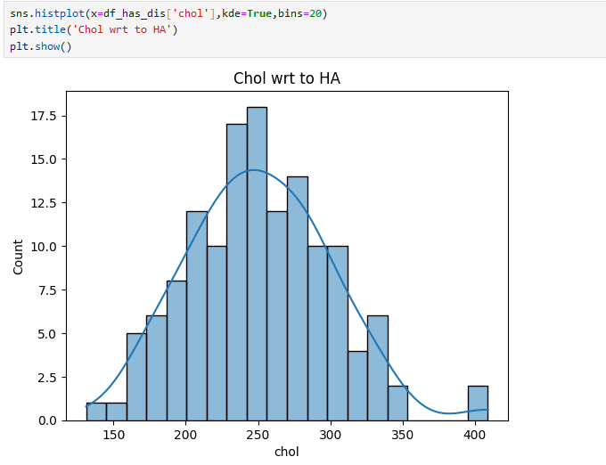

Analysis:

most heart disease patients have cholesterol levels in this **range (200-300 mg/dl)**

1. **Exercise peak w.r.t to heart 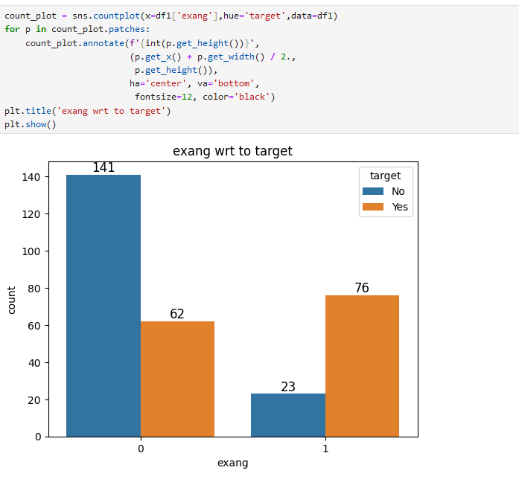disease:**

Analysis:

Data with patients doing exercise peak have **more heart disease(76).**

1. **Understanding Relationships between all variables**

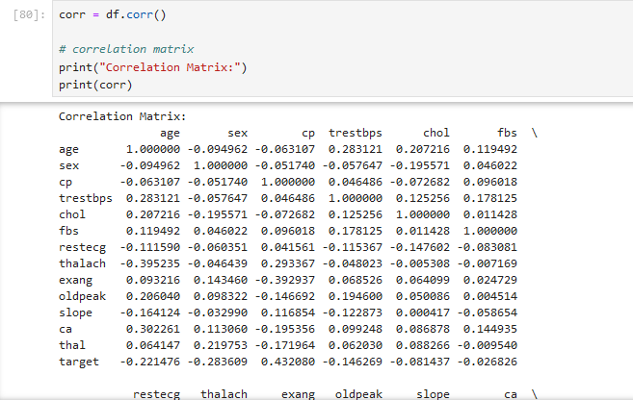

Analysis:

Chest Pain Type (cp) has a strong positive effect on the target with a correlation of 0.4321, meaning more severe chest pain is linked to a higher chance of the target condition. Exercise Induced Angina (exang) has a strong negative effect, with a correlation of -0.4356, indicating that those with angina are less likely to have the target condition. Oldpeak has a negative effect (-0.4291), where higher values suggest a lower likelihood of the target. Finally, Maximum Heart Rate (thalach) shows a positive effect with a correlation of 0.4200, meaning higher heart rates are associated with a higher chance of the target condition.

1. **Regression Analysis:** 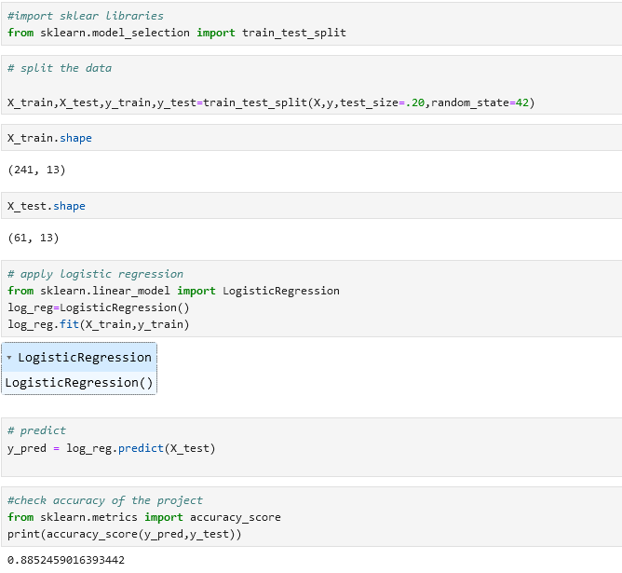

**Analysis**

**The model successfully achieved 88% success of prediction.**

1. **Export data into xlsx file cleaned_data.**xlsx to work on Tableau.
2. **Dashboard**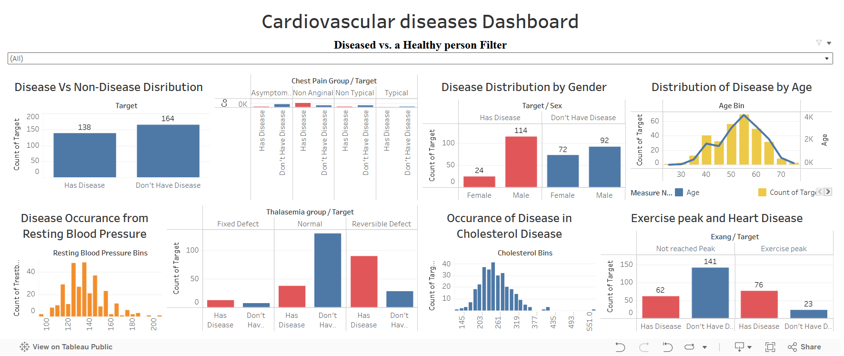

Dashboard demonstrates the necessary charts and filter to understand attributes of a Diseased vs. a Healthy person.